SOFIA UNIVERSITY

ST. KLIMENT OHRIDSKI



FACULTY OF ECONOMICS AND BUSINESS ADMINISTRATION

Topic: Portfolio optimization of 5 assets in Nasdaq 100 Index.

Author: Ani Petkova

Student number: 1EB4100326

MSc Program: Business Analytics

**Table of Contents** Page

1.Introduction **3**

2.Dataset **3**

3.Daily Prices and Returns **4**

4. Standard deviation **5**

5.Covariance matrix **6**

6. CvaR **7**

7. Portfolio Optimization  **8**

8. Conclusion **9**

**1.Introduction**

The most fundamental part of portfolio optimization is the balance between risk and return. In the following pages we will try to optimize a portfolio of 5 randomly selected assets. We will use several measures of risk, such as: Standard Deviation, Conditional Value at Risk and the Covariance matrix which not only tells us the risk associated with each asset but also measures the degree to which two assets move together.

For a portfolio to be optimal it needs to achieve a higher expected return which requires taking on more risk. This risk-return relationship is graphically represented by a curve known as the efficient frontier.

**2.Dataset**

Portfolio optimization is based on Modern Portfolio Theory ([MPT](https://www.wallstreetmojo.com/modern-portfolio-theory/)) and one of the key components of MPT is diversification. Therefore, for the purpose of this paper we will be working with 5 randomly selected companies from various industries part of the Nasdaq 100 Index. Through diversification a portfolio's overall risk may be reduced owing to the fact that if one investment is performing poorly, another investment in the portfolio may be performing well, offsetting the losses. The companies* included in the portfolio are Apple Inc. (AAPL), Monster Beverage Corporation (MNST), Netflix, Inc. (NFLX), PayPal Holdings, Inc. (PYPL), AstraZeneca PLC (AZN).

Apple Inc. is an American [multinational](https://en.wikipedia.org/wiki/Multinational_corporation) [technology company](https://en.wikipedia.org/wiki/Technology_company) headquartered in [Cupertino, California](https://en.wikipedia.org/wiki/Cupertino,_California). Apple is the world's [largest technology company by revenue](https://en.wikipedia.org/wiki/List_of_largest_technology_companies_by_revenue), with [US$](https://en.wikipedia.org/wiki/United_States_dollar)394.3 billion in 2022 revenue. As of March 2023, Apple is the [world's biggest company by market capitalization](https://en.wikipedia.org/wiki/List_of_public_corporations_by_market_capitalization). It is considered one of the [Big Five](https://en.wikipedia.org/wiki/Big_Tech) American [information technology](https://en.wikipedia.org/wiki/Information_technology) companies.

Monster Beverage Corporation is an American [beverage company](https://en.wikipedia.org/wiki/Beverage_company) that manufactures [energy drinks](https://en.wikipedia.org/wiki/Energy_drink). As of 2020, Monster held 39% of the $86 billion global energy drink market, the second highest share.

Netflix, Inc. is an American media company based in [Los Gatos, California](https://en.wikipedia.org/wiki/Los_Gatos,_California). The company is ranked 117th on the [Fortune](https://en.wikipedia.org/wiki/Fortune_500) [500](https://en.wikipedia.org/wiki/Fortune_500) and 219th on the [Forbes Global 2000](https://en.wikipedia.org/wiki/Forbes_Global_2000). It is the second largest entertainment/media company by [market capitalization](https://en.wikipedia.org/wiki/Market_capitalization) as of February 2022. During the 2010s, Netflix was the top-performing [stock](https://en.wikipedia.org/wiki/Stock) in the [S&P 500](https://en.wikipedia.org/wiki/S%26P_500) [stock market index](https://en.wikipedia.org/wiki/Stock_market_index), with a total return of 3,693%.

PayPal Holdings, Inc. is an American multinational financial technology company operating an online payments system in the majority of countries that support [online money transfers](https://en.wikipedia.org/wiki/E-commerce_payment_system), and serves as an electronic alternative to traditional [paper](https://en.wikipedia.org/wiki/Banknote) methods such as [checks](https://en.wikipedia.org/wiki/Cheque) and [money orders](https://en.wikipedia.org/wiki/Money_order). Established in 1998 as Confinity, PayPal went public through an [IPO](https://en.wikipedia.org/wiki/Initial_public_offering) in 2002. It became a wholly owned subsidiary of [eBay](https://en.wikipedia.org/wiki/EBay) later that year, valued at $1.5 billion. In 2015 eBay [spun off](https://en.wikipedia.org/wiki/Corporate_spin-off) PayPal to its shareholders, and PayPal became an independent company again. The company was ranked 143rd on the 2022 [Fortune 500](https://en.wikipedia.org/wiki/Fortune_500) of the largest United States corporations by revenue.

AstraZeneca plc  is a British-Swedish multinational [pharmaceutical](https://en.wikipedia.org/wiki/Pharmaceutical_industry) and [biotechnology](https://en.wikipedia.org/wiki/Biotechnology) company with its headquarters at the [Cambridge Biomedical Campus](https://en.wikipedia.org/wiki/Cambridge_Biomedical_Campus) in [Cambridge](https://en.wikipedia.org/wiki/Cambridge), England. It has been involved in developing the [Oxford–AstraZeneca COVID-19 vaccine](https://en.wikipedia.org/wiki/Oxford%E2%80%93AstraZeneca_COVID-19_vaccine). AstraZeneca has a primary listing on the [London Stock Exchange](https://en.wikipedia.org/wiki/London_Stock_Exchange) and is a constituent of the [FTSE 100 Index](https://en.wikipedia.org/wiki/FTSE_100_Index).

We will be working with the adjusted close prices taken from March 1st 2020, up until March 1st 2023

*Information about the companies is gathered from Wikipedia

**3. Daily Prices and Returns**

Looking at the daily prices of each asset we can see that NFLX and PYPL have significant fluctuations. At the begging of the given period NFLX’s price was 381.05$, gradually increasing to its peak 691.69$ on 17th November 2021 and going below the starting numbers at the end of the period - 322.13$. Being the most volatile product in this portfolio, NFLX is also the most profitable. Second most volatile is PYPL and the more stable products are AAPL, MNST and AZN, with which we observe a gradual increase of prices over time.

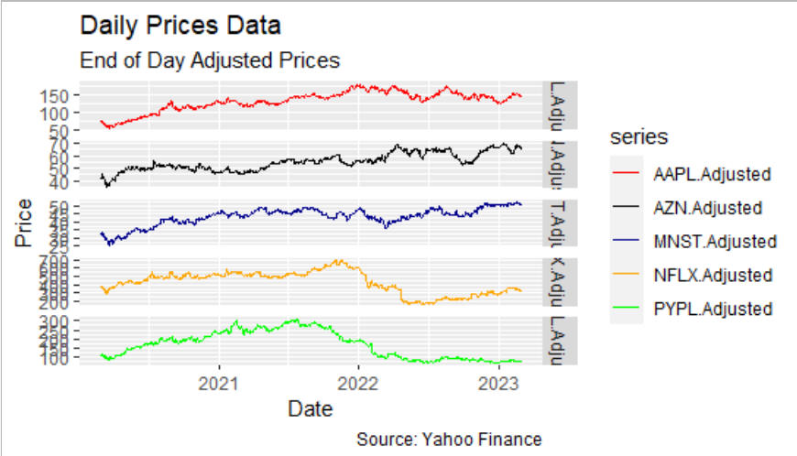

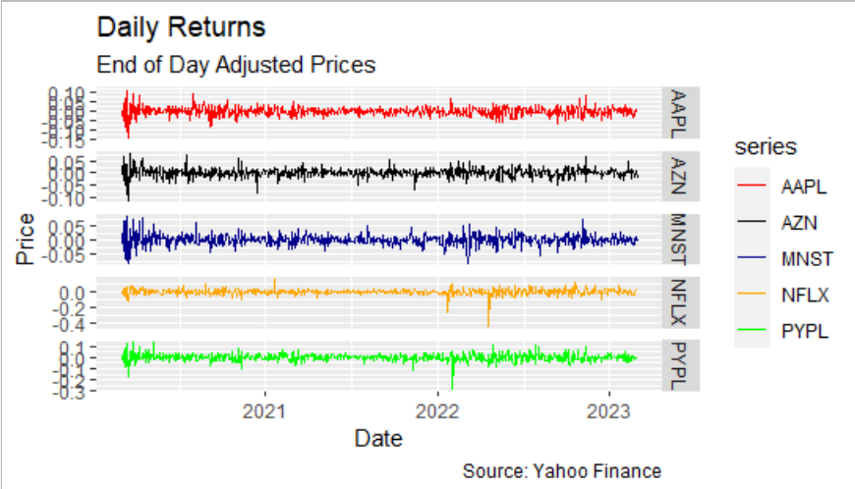

Fig.1

**4.Standard Deviation**

The most frequently used measurement of [investment](https://icfs.com/certified-fund-specialist) risk is standard deviation.In our case we have a portfolio standard deviation of 0.01885357 which is considered a relatively low risk.

We will now look at each asset’s standard deviation.



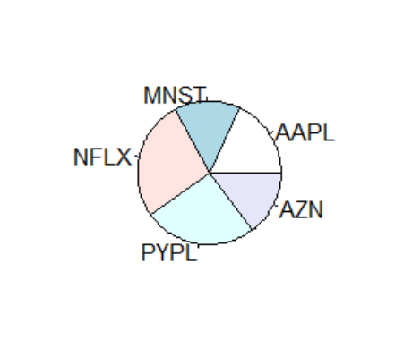

Fig.2

As we can see from both the table and the pie chart, AZN and MNST have the lowest standard deviation of 0.018 which signifies more stable returns. Next is AAPL with 0.022. The assets with the highest standard deviation are PYPL and NFLX with respectively 0.032 and 0.034 which indicates greater volatility. These results further confirm our findings in the previous section.

By choosing a portfolio with standard deviation that is less than the standard deviation of the included assets we can reduce the volatility of the portfolio as a whole. It is in our interest to create an optimal mix of higher-volatility assets with lower-volatility assets. By doing that we can reduce risk and still allow for a positive return.

**5. Covariance Matrix**

The covariance matrix tells us two important things about our portfolio. The diagonal elements represent the risk level of each asset. The rest of the elements measure the degree to which two assets move together. A positive covariance indicates that the returns tend to move in the same direction and not in the opposite directions.

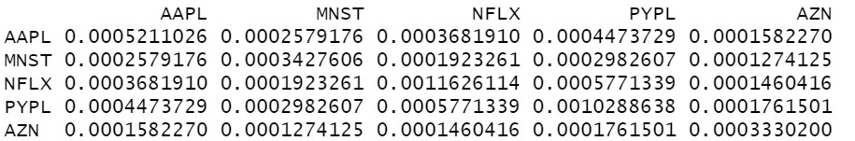

Evidently, the covariances between all of the assets in our portfolio are positive.

For optimal results we would want to select assets with low or negative covariances in order to reduce overall portfolio risk and enhance potential returns. However, since our portfolio was randomly selected this criterion was in fact not met.

**6. CvaR**

Conditional Value at Risk (CvaR), also known as Expected Shortfall (ES) provides an estimate of the potential loss in extreme market conditions, which can be used to quantify the risk associated with a portfolio. It is calculated as the average of the losses that exceed the VaR threshold, providing an estimate of the expected loss in the tail of the loss distribution.

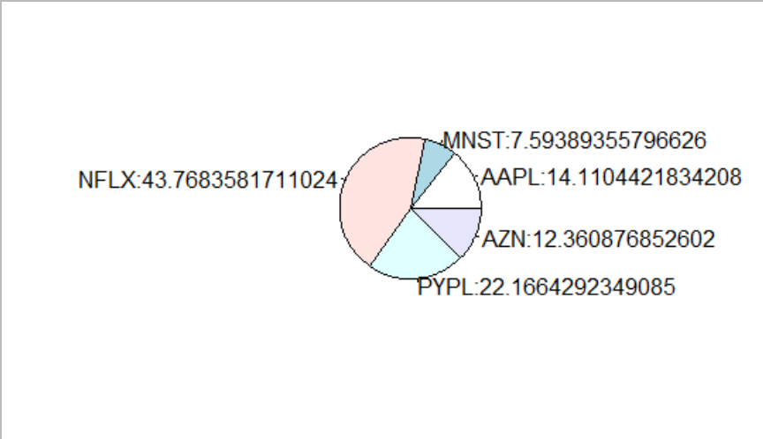The confidence level used in out CvaR calculations is 95%.

Fig.3

As we can see, NFLX contributes to the overall portfolio risk with almost 44%, followed by PYPL with 22% contribution. AAPL and AZN have relatively low impact with 14.11% and 12.36%. And contributing to the risk with just 7.59% is MNST.

**7. Portfolio Optimization**

An optimal portfolio is said to have the highest [Sharpe ratio](https://www.wallstreetmojo.com/sharpe-ratio/), which measures the excess return generated for every unit of risk taken. Hence, we will be constructing an efficient frontier by generating random portfolios for a combination of the five assets.

We will first start by setting some constraints to our portfolio. We add box constraints for the asset weights so that the minimum weight of any asset must be greater than or equal to 0.05 and the maximum weight of any asset must be less than or equal to 0.8. The full investment constraint means that the weights must sum to 1. We proceed to generating 1000 random portfolios that satisfy these constrains.

As a next step we will add objectives to the portfolio. The first one is a risk objective which aims to minimize portfolio expected tail loss. We also add a return objective to maximize the portfolio mean return.

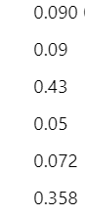Here is an example of optimal weights for a portfolio with minimum risk:

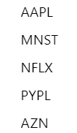

This basically tells us that among the given five options if we were to invest 9%, 43%, 5%, 7% and 35% of share of wealth in AAPL, MNST, NFLX, PYPL and AZN respectively then we would have minimized our risk.

An example of optimal weights for a portfolio with maximum returns are:

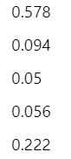

Now, in order to find the combination of weights that provides the best portfolio return for a given level of risk, we create the Efficient Frontier.

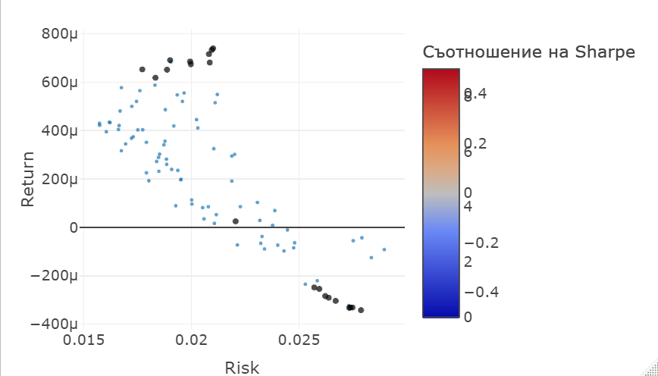 Fig.4

**8.Conclusion**

In conclusion the Efficient Frontier represents graphically portfolios that maximize returns for the risk assumed, showing the benefit of diversification.

To use the efficient frontier, an investor that seeks more risk selects portfolios that fall on the right side of the frontier. On the other hand, a more conservative investor would want to pick portfolios that lie on the left side of the frontier.

## **References**:

<https://icfs.com/financial-knowledge-center/importance-standard-deviation-investment>

<https://www.investopedia.com/>

<https://en.wikipedia.org>

<https://medium.com/analytics-vidhya/plot-stock-prices-with-r-6bdbaebc8ec1>:

<https://blog.quantinsti.com/calculating-covariance-matrix-portfolio-variance/>

<https://finance.yahoo.com/>

https://www.investopedia.com/terms/e/efficientfrontier.asp

https://www.investopedia.com/terms/c/conditional_value_at_risk.asp